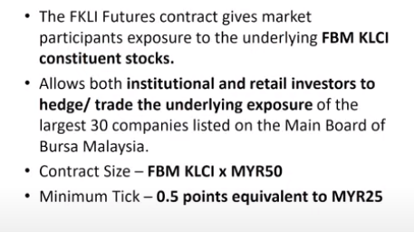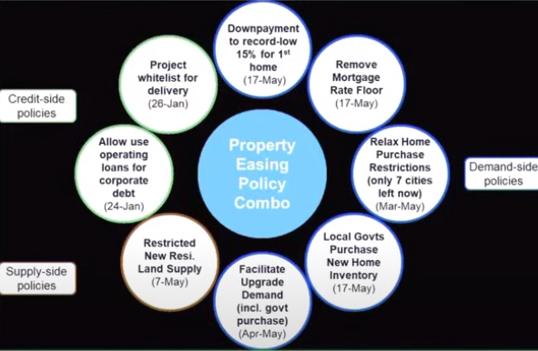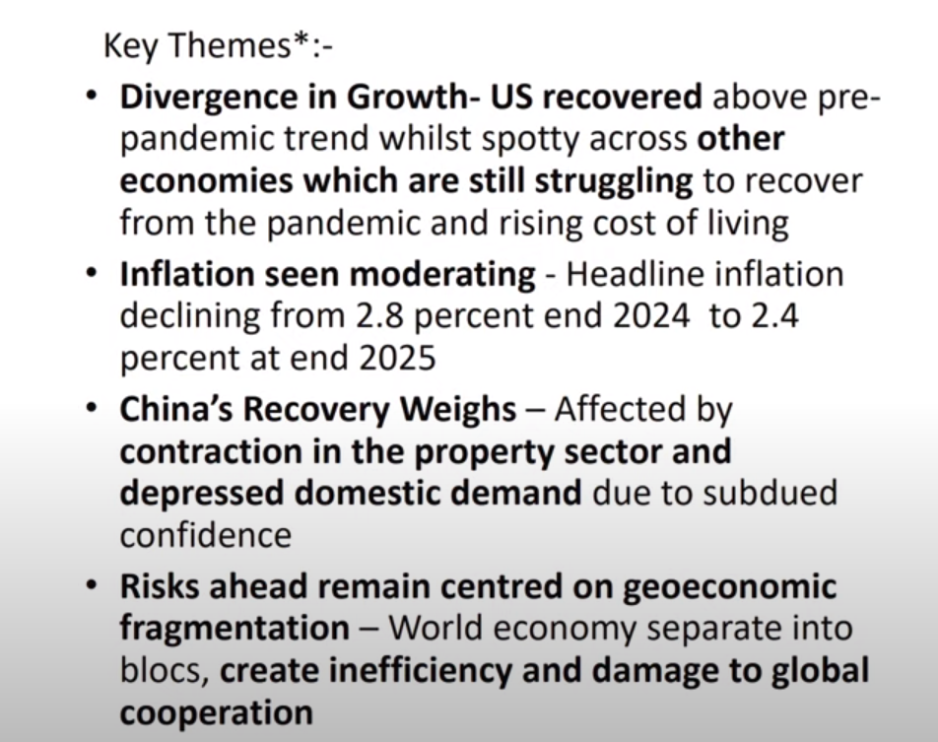

-CHINA IS GOINF TRHU TRANSITION. China gov knows is not a good thing to hold too many debt & their population is aging. Trying to push manufacturing.

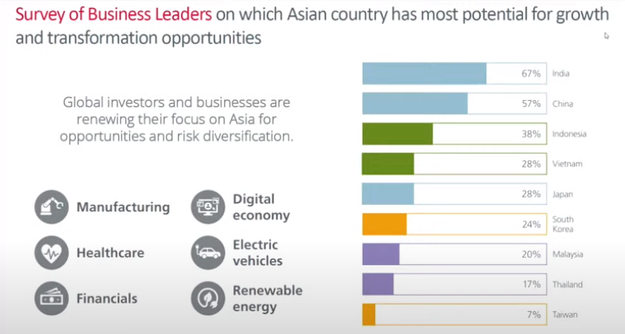

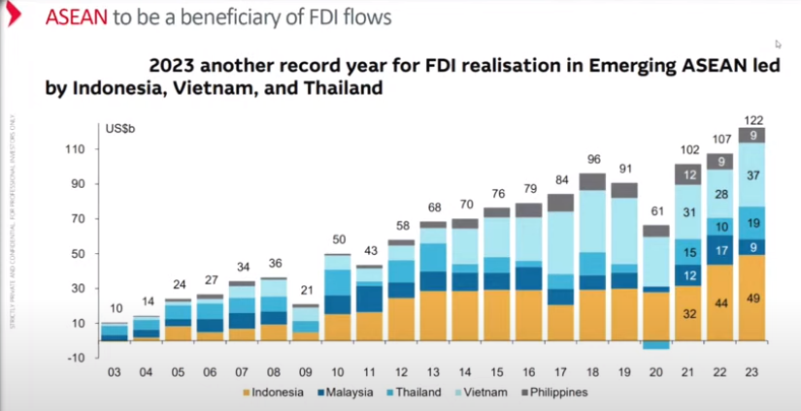

If Donald trump won the election, he said he would slap 60% of china and 105 for the rest of the company. So for the ones that align with china would get affected, who are the one? Vietnam fdi would prolyl be affected. However, the rest of the asean countries would gt benefits out of it.

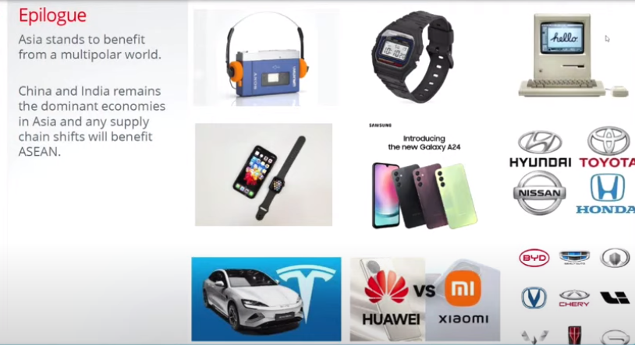

-news about msia joining brics, isit a good move? No, its similar to india, it’s a beneficial of brics & still good with US. Its like join in a club membership, you still able to ply in diff golf club even join new golf club.

- Whether anot china can grow precovid, is how they address the property sector. The put in key measures to address the property sector. Secondly the youth unemployment rate is still very high, the youth that is coming to workforce, they are the one have the money to spend. Once the get the salary they want to buy this buy that. Obviously if don’t address the youth segment it’s gonna be the key issue and tha is why we don’t see china going back to their aggressive growth as compared to their haydays. Thirdly bcoz us is always punishing them, external factors are also affecting them postcovid.

-india valuation is expensive but we always make money in india. The reason being is many investors out there don’t understand India market. IM is expensive for a reason. They will nominate india’s valuation with their growth, so a lot of these indian growth company has already reach so called far value but the domestic participation by indian investors is tremendous. Everytime the foreigner is selling, local investors are actually buying back. So india market is a very unique mrkt in the sense that expensive but it has performed. So it doesn’t mean that we have to throw out the textbook theory that cheap value it will outperform. Sometimes expensive wil outperform, when we look through why is this expensive we can actually narrow down into factor investing. India when they perform is always driven by momentum. Momentum story here in india is actually very strong & why is india having this momentum, you tie back to their economics they are doing well in terms of growth. Secondly their corp expanding capacity. Thirdly they able to deliver their earnings.

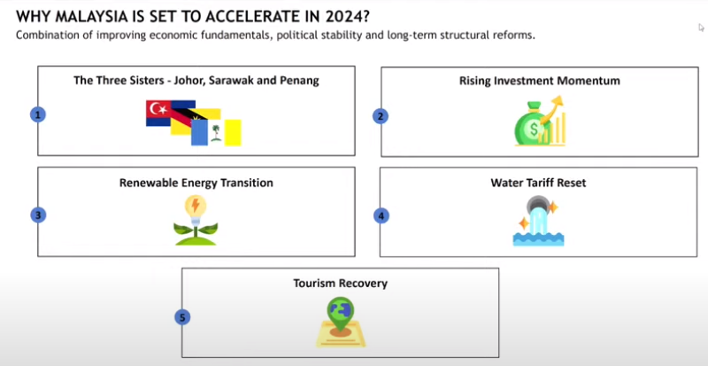

https://docs.google.com/forms/d/e/1FAIpQLScq6udZFY7JzSEg3CXkBYhjlhadFOE3k0IXvkHk45BzywKswg/viewform?usp=pp_url&entry.2108874424=CHAI+YAN+QI&entry.1560493947=940325105186&entry.1562756213=5&entry.765727405=5&entry.766506252=3&entry.246057591=4&entry.1894922762=1&entry.1270295986=Options,+futures&entry.131382149=bursa&entry.1251855340=Philip+Mutual+Berhad&entry.1256819273=Eastspring+Investments+Dinasti+Equity+Fund&entry.1395121094=Malaysia&entry.1273158376=4&entry.1593357212=5&entry.209835365=3&entry.597415336=5&entry.1515825979=4&entry.292832338=5&entry.1640019951=3&entry.1081328572=5&entry.1454383158=5&entry.1901257379=5&entry.1407321074=3&entry.1195270033=4&entry.1458220231=4&entry.99241268=4&entry.1351198753=4&entry.1194931585=4&entry.277051744=3&entry.388131834=4&entry.698637761=3&entry.1688711687=3&entry.379001060=4&entry.260327504=4&entry.125513804=4&entry.1350983786=5&entry.531254928=5&entry.598362538=5&entry.352073272=4&entry.506626213=5&entry.1676430492=5&entry.2039693056=5&entry.1635132977=4&entry.1143287155=4&entry.396996086=4&entry.2131329467=4&entry.1929640551=4&entry.1183332190=4&entry.2144246878=4&entry.461707917=4&entry.1157425390=4&entry.497940520=4&entry.1248941089=4&entry.648545525=4